OMFS Survival Guide – MRCS

Pathology

* Inflammation
  + Sinus = blind ending tract
  + Complement is part of innate immune system
  + Mediators

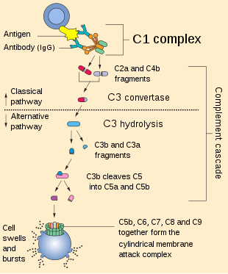

* + - IL1 – neutrophil adhesion
    - Il2 – differentiation of B cells and NK cells
    - Histamine – increased capillary permeability
    - Interferon – activate macrophages and NK cells
    - TNF – fever, neutrophil adhesion
    - IL8 attracts neutrophils
* Cell Injury
  + Mitochondria can self replicate
  + Ageing cells = lipofuscin
* Wounds
  + Woven bone replaced by lamellar bone
* Vascular
  + Central line insertion
    - Immediate complications – pneumothorax, haemothorax, embolism, haematoma, chylothorax, tamponade, arrhythmias

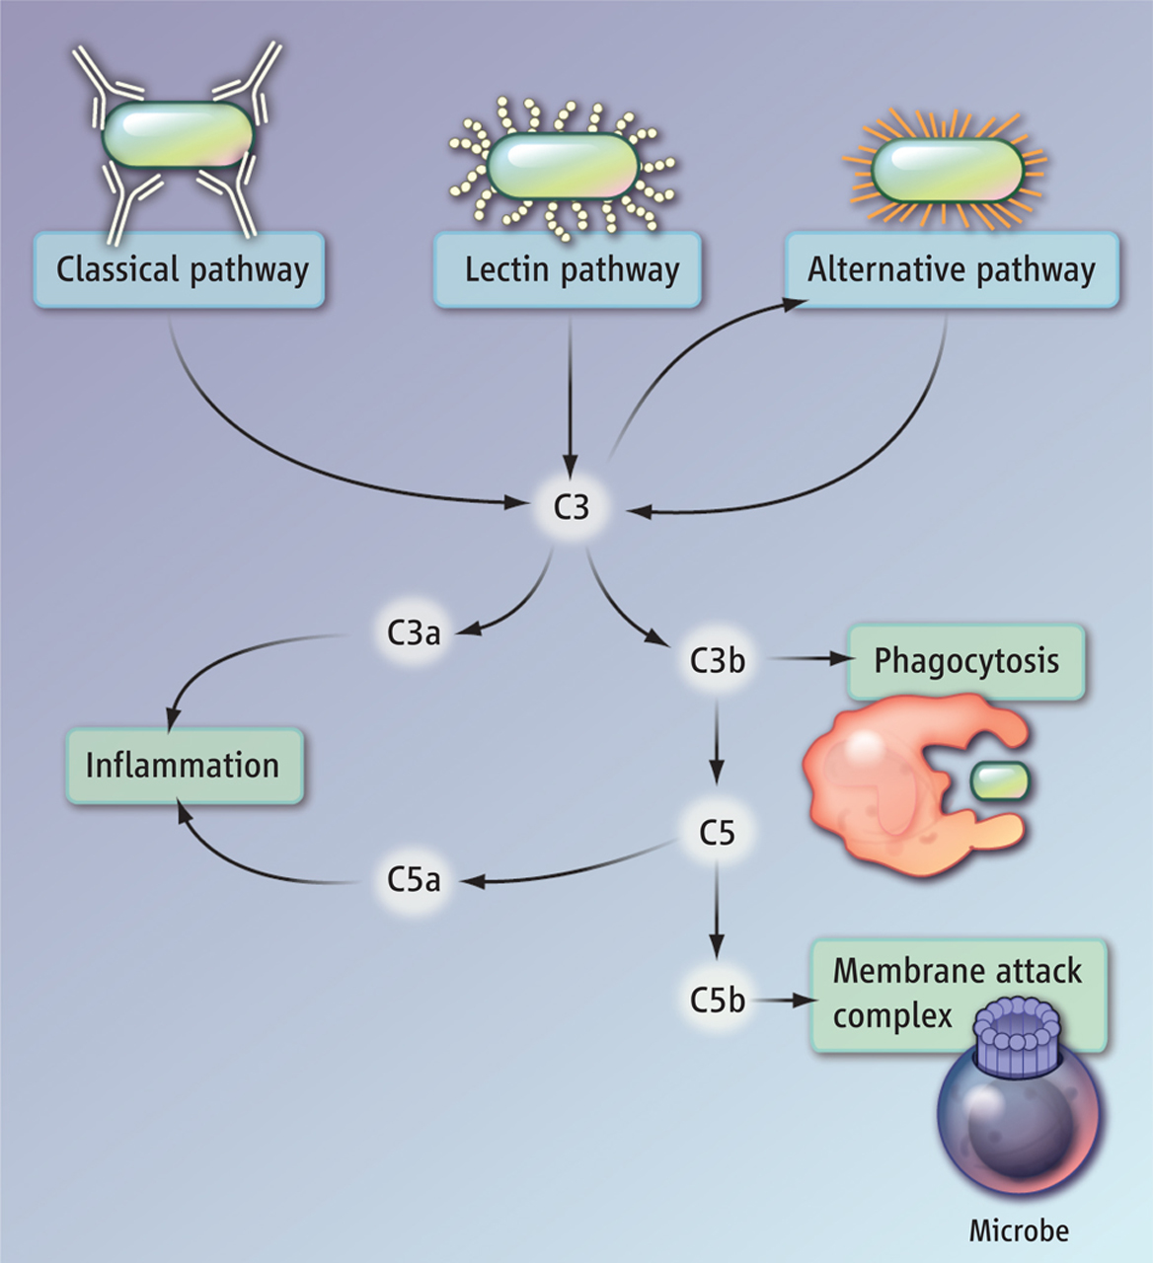

* + Ulcers
    - Arterial – punched out, poor cap refill, absent pulses, painful
    - Diabetic – pressure areas, painless
  + Ascites
    - Transudate – LOW protein – failure
    - Exudate - HIGH protein – infection
* Growth
  + Cornea lined with stratified squamous epithelium
  + Dysplasia can be reversed if caught early
  + Metaplasia = reversible transformation of cells from one type to another
  + Hyperplasia/hypertrophy can be reversed when stimulus removed
  + Gangrene
    - Wet – arterial and venous obstruction

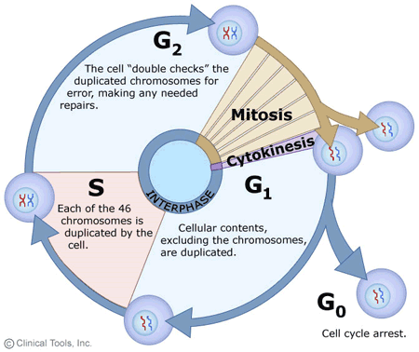

* + - Gas – c. perfringens
    - Dry – slow putrefactive process
  + Genetics
    - Wilsons disease – chromosome 13
    - Haemochromatosis – chromosome 6
    - A1 antitrypsin is autosomal recessive
  + Apoptosis – cell membrane integrity is preserved, no inflammatory response
    - Can be morphogenetic
* Cancer
  + Rhabdomyosarcoma = skeletal muscle neoplasm
  + Oesophageal/stomach cancer – nitrosamine
  + Adenomas can become malignant (adenocarcinoma)
  + Colon cancer – linked to low vit c diet and low fibre intake
  + Osteosarcoma most common bone primary
  + Gastric cancer – link to blood group A
  + Auer rods = AML
* Immunology
  + Virus infected cells killed by NK cells
  + Complement
    - Classical – antigen to C1/2/4 🡪 C4b2a 🡪 C3 a and b 🡪 anaphylaxis/c5 convertase
    - Alternative – endotoxin cleaves C3 🡪 c3 a and b 🡪 c5 convertase
    - Final common – c5 convertase 🡪 c5a (anaphylaxis), c5b (MAC)
* Haematology
  + Warfarin can’t be used in later stages of pregnancy
  + Most common cause of thrombosis is atherosclerosis
  + ITP – low platelets, autoantibodies to platelets, megakaryocytes, bruises
  + B12 deficiency can cause de-myelination of posterior and lateral columns of spinal cord
  + Protein c degrades factor 5a and 8a
  + Iron deficiency anaemia
    - Target cells and pencil cells
    - Low ferritin, high transferrin
  + Sickle cell = mutation of beta haemoglobin chain
  + Shelf life of platelets is 5 days
* Microbiology
  + Clostridium = gram positive rods

Pathology Key Revision Points

* Sarcomas
  + 40% in extremities
  + Mesenchymal
    - Bone or soft tissue
  + IM location, rapid growth, painful
  + Ezamples
    - Ewings – males, teenagers, femoral diaphysis, blood mets and tx = chemo = surgery
    - Osteosarcoma – osteoblastic differentiation, tx = chemo + surgery
* Thyroid tumours
  + Solitary nodules – do FNA first line
  + Follicular
    - Discrete nodule
    - Cant be diagnosed via FNA so all THY 3f will require at least hemi thyroidectomy
    - berrys sign (absence of carotid pulse due to malignant thyromegaly)
    - metastasise away from thyroid (ie skull) – spread via blood
  + Papillary
    - Commonest
    - Diagnosed on FNA
    - Psammoma bodies (organ Annie nuclei)
    - Mets confined to neck (spread via lymph)
  + Anaplastic
    - Elderly females
    - Mostly palliative management as present late
  + Medullary
    - Parafollicular cells (c cells) and neural crest origin
    - High calcitonin levels (used for monitoring)
    - Linked to MEN 2A
    - Don’t respond to radioiodine
  + Lymphoma
    - Respond well to radiotherapy
* Mesenteric infarcts
  + 50% linked to acute emboli affecting SMA (due to AF or post-MI)
  + Likely at splenic flexure (territory supplied by both SMA and IMA)
  + Presentations
    - Acute emboli – sudden onset pain and diarrhoea, clinical deterioration
    - Acute on chronic – longer history, post-prandial abdo pain and weight loss
    - Vein thrombosis – weeks history, signs will not present until vein thrombosis impacts arterial flow
    - Linked to thrombophilia
  + Ix – CT angiography
  + Tx
    - periotnism = laparotomy
    - vein thrombosis – IV heparin
* TB
  + Ghon complex = lung lesion and lymph nodes
  + Forms granuloma (collection of histiocytes)
  + **Caseous** necrosis in the centre
  + Type 4 hypersensitivity
* Arterial occlusions
  + Embolus - sudden
  + Thrombosis - cladication
  + Vasospasm – extremities, Raynauds, temperature related
  + Steal syndrome – secondary to AV fistula or cervical rib
  + Vasculitis
    - Aorta – Takayasus/buergers/temporal arteritis
    - Large arteries – buergers/temporal arteritis/polyateritis nodosa
    - Medium arteries – polyarteritis nodosa/wegeners granulomatosis
    - Small arteries – wegners granulomatosis/rheumatoid vasculitis
  + Specifics
    - Takyasu’s = upper limb claudication, diminished pulses, ESR high
    - Buergers = thrombotic occlusions, young male smokers, pedal pulses lost, corkscrew collateral vessels
    - GCA = granulaomatous lesions on biopsy however biopsy may be normal
* Oesophageal Cancer
  + Adenocarcinoma – lower part of oesophagus
    - GORD history/barrets oesophagus
  + SCC – upper part of oesophagus
    - Tx = chemoradiotherapy
* Haematuria
  + Causes
    - Trauma
    - Infection
    - Malignancy – renal cell carcinoma, TCC of bladder, wilms tumour (children), prostate cancer, penile cancer
      * Transitional cell carcinoma = arise from urothelium
    - Renal disease – glomerulonephritis
    - Stones
    - Drugs – cause tubular necrosis/nephritis
* Pagets diease of breast
  + Rash affects nipple first then spreads to areolar area
  + Diagnosed via punch biopsy
* Breast cancer
  + Nottingham Prognostic Index – (tumour size x 0.2) + lymph node score + grade score
  + Tx – small breasts and big lump = mastectomy; large breasts and small lump = WLE
  + Reconstruction uses latissimus dorsi flap and sub-pectoral implants (prosthesis/TRAM/DIEP flaps)
* Parathyroid
  + Primary hyperparathyroidism and renal stones = indication for parathyroidectomy
  + Types
    - Primary = high PTH, calcium; low phosphate
      * Surgery if poor renal function, neuromuscular symptoms, renal stones, T score less than -2.5
    - Secondary = high PTH, phosphate; low calcium – background of chronic renal failure causing parathyroid gland hyperplasia
      * Medical therapy
    - Tertiary = high PTH, calcium, ALP; low phosphate – ongoing hyperplasia post transplant
      * Excise gland and re-implant
    - Familial – low calcium in urine
* Liver lesions
  + Liver cell adenoma linked to COCP
  + Haemangioma – most common benign tumour
  + Abscess – linked to biliary sepsis
  + Amoebic abscess – aspirates colourless fluid – give metronidazole
  + Hyatid cyst – echinococcus infection – give mebendazole
* Cell death
  + Necrosis – loss of perfusion 🡪 hypoxia 🡪 cellular lysis
    - Coagulative – organs
    - Colliquative – CNS
    - Caseous.- TB, eosinophils
    - Gangrene – iron sulphide (wet component is liquefactive)
    - Fibrinoid – arterioles in patients with malignant hypertension
    - Fat – trauma to fat
  + Apoptosis – programmed cell death
* Lymphoma
  + Hodgkins
    - classical lymphocyte predominant is best prognosis
    - Ann Arbor staging
    - Reed Sternberg cell
    - Tx = chemo and radio
    - Linked to EBV
* Jaundice
  + USS first line
  + CT if ?pancreatic necrosis
  + MRCP then ERCP
* Diaphragm disease
  + Small bowel divided into short compartments
  + Caused by NSAIDs
* Hereditary Spherocytosis
  + Red cell membrane – prone to destruction
  + High bilirubin, jaundice, splenomegaly
* Carcinoid tumour
  + Neuroendocrine tumour secreting serotonin
  + Carcinoid syndrome only occurs in presence of liver mets as liver metabolises serotonin from primary lesion normally
  + Blood tests – chromogranin A, NSE, substance P, gastrin
  + Urine tests – 5 HIAA (serotonin)
  + Tx: octreotide/excision
* Haematology
  + Antiphospholipid syndrome = thromboembolism and bleeding in young woman
    - Low platelets, APTT prolonged
  + DIC
    - Low platelets and high fibrin degradation products
* Genetic Disoders
  + Colorectal
    - Lynch Syndrome (HNPCC) – colon, uterine, gastric cancer
    - FAP (APC gene) – colon, duodenal cancer
      * Gardner syndrome is FAP with desmoid tumours (myelofibroblasts) and mandibular osteomas
    - Villous polyps have greatest risk of metastatic potential
      * Moderate/high risk need regular colonoscopy
    - Peutz-Jeghers
      * Autosomal dominant
      * Harmartomatous polyps and pigmented freckles, intussusception
  + Oesophageal
    - Choanal atresia – episodes of cyanosis worse during feeding and better on crying
* Hepatocellular carcinoma
  + Those at risk (hepatitis, cirrhosis) should receive USS/AFP every 6-12 months
  + Child Pugh score
    - A – resection
    - B – chemo (tyrosine kinase inhibitor SORAFENIB)
    - C – best supportive care
* Bone pathology
  + Pain at rest, high calcium, high ALP = mets to bone
    - Requires radiotherapy
  + Pagets disease of bone – very high ALP (normal calcium)
    - Give bisphosphonates
  + Osteoporosis – give bisphosphonates
* Pancreatic Cancer
  + Adenocarcinoma
  + Trousseau’s sign – migratory superficial thrombophlebitis
  + Tx
    - Head of pancreas – whipples
    - Body/tail – distal pancreatectomy (poor prognosis)
* Nasopharyngeal carcinoma
  + Linked to EBV
  + Squamous cell carcinoma
  + Unilateral conductive hearing loss + ipsilateral face pain + ipsilateral paralysis of soft palate
  + Tx = radiotherapy
* Actinomycosis
  + Gram positive anaerobes
  + Sulphur granules
  + Tx = penicillin based antibiotics
* Fracture Complications
  + Symptoms: resp, neuro, petechial rash
* Crohns Management
  + Segmental small bowel resections/stricturoplasty
  + Risk of intestinal fistulas
* Testicular Cancer
  + Seminoma – normal AFP and HCG
  + Teratoma – twenties, high AFP
* Phaeochromocytoma
  + Ix – urinary VMA
  + Tx – medically optimise (alpha blocker and beta blocker) then remove
* Definition
  + Neuropraxia.= nerve loss which recovers
  + Giant cell = made from macrophages
* Parotid Cancer
  + Adenoid cystic carcinoma most likely to invade nerve
* Anal Cancer
  + Commonly squamous cell carcinoma
* Renal Disease
  + Poor renal function + muddy brown casts = acute tubular necrosis
    - Myoglobinuria and haemolysis cause necrosis
  + Acute interstitial nephritis – due to drug toxicity
  + Renal tumours
    - Renal cell carcinoma is brown
    - Transitional cell carcinoma is pink
* Aneurysm disease
  + Loss of elastic fibres from the media
* Pagets disease of bone
  + Primary disorder of osteoclasts followed by increased osteoblastic activity causing sclerosis
  + Causes sensorineural hearing loss
* Ureters lined by transitional epithelium
* Meckels
  + Usually ileal mucosa but can be lined with ectopic gastric mucosa